1. How to debug JavaScript code:

Mistakes made by developers while writing code are called errors/bugs. Debugging is the process of fixing the bug by testing, finding, and removing bugs/errors from the program.

There is no specific way of debugging client-side JavaScript, except the only way to debug JavaScript is through the browser. Fortunately, all browsers have their own built-in debugging tool that makes it easier to debug.

* Firefox has Firebug to debug
* Chrome and Internet Explorer have Web developer tools, debugging can be seen in the browser by pressing the F12 key and selecting console from the debugger menu.
* Modern browsers have a JavaScript console screen (press F12 Key) under the developer tool where errors in JavaScript’s are reported

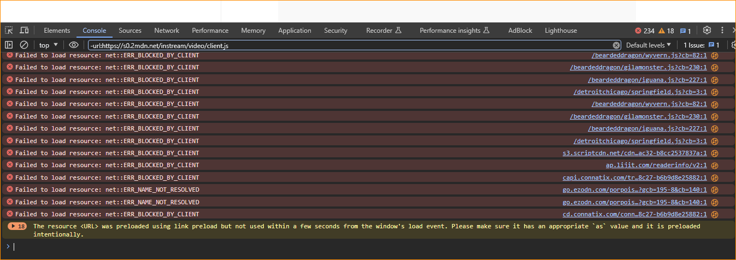

* JavaScript Console Object

The Console object exists only if there is a debugging tool supported by the browser.

**console.log()** is used to display JavaScript values in a console window under the debugging tool of the browser. It is used to write a log message at runtime. For example

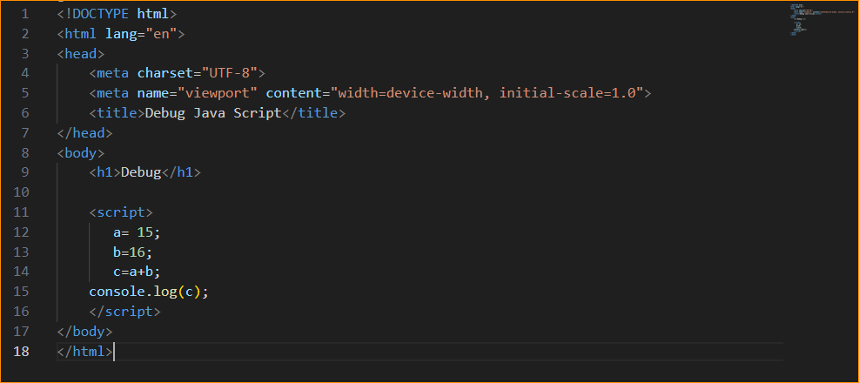

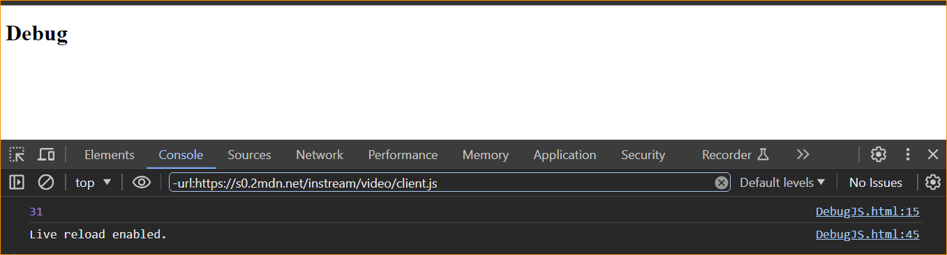

1. Using debugger Keyword

Another way of debugging the JS code is by using the debugger keyword. It stops the execution of JavaScript the same as setting a breakpoint in the code. When the code execution reaches the line where the debugger is mentioned, it will stop executing from that point before it executes the next line.

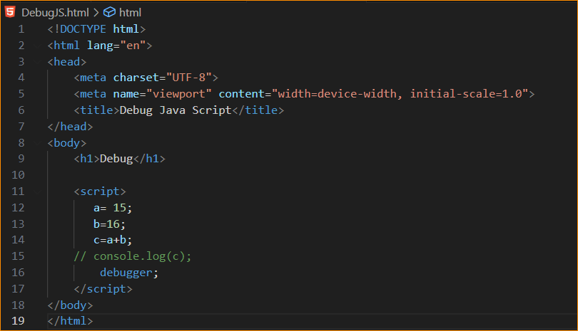

Result-

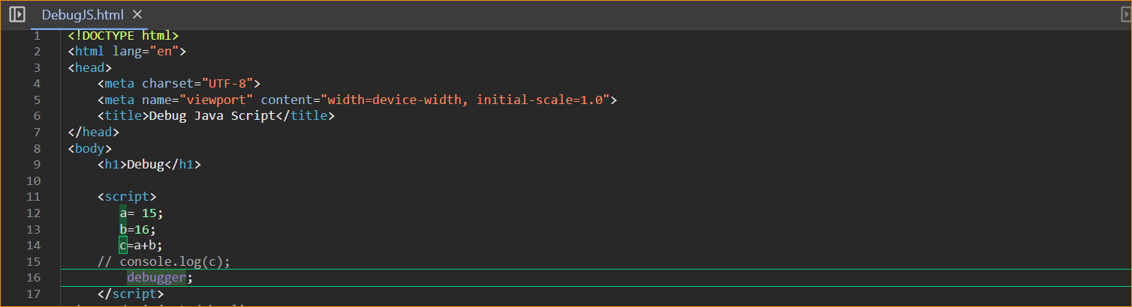

31- Can check value

Chrome:

* Open the Chrome browser.
* From the Chrome menu select “More tools”.
* From More tools select “Developer tools”.
* In the end, select the Console window.